|  |  |  |  |  |  |
| --- | --- | --- | --- | --- | --- |
| Date | 24-Nov-22 | | | Tester Name | Andrew McLaughlin |
| Environment | Penfax - Test | | | Login used |  |
| Operating System | Select OS | Version: | Update: | | |
| Software Used | Select Software | Version: | Update: | | |
| Select Software | Version: | Update: | | |
| Release version | 22.4.1 | | | | |
| Title | Enter Death Date | | | | |
| Test Type | Regression | | | | |
| Test Scenario | Enter Death Date | | | | |
|  |  | | | | |
| Expected Results | * We should be able to add death date * The Death Date should be reflected under the member’s Person Profile | | | | |
| Pass/Fail | Pass | | | JIRA# | N/A |

Describe your steps with screenshots:

Under Person Profile, Edit the Person Summary and Add the Date of Death. Hit Save. 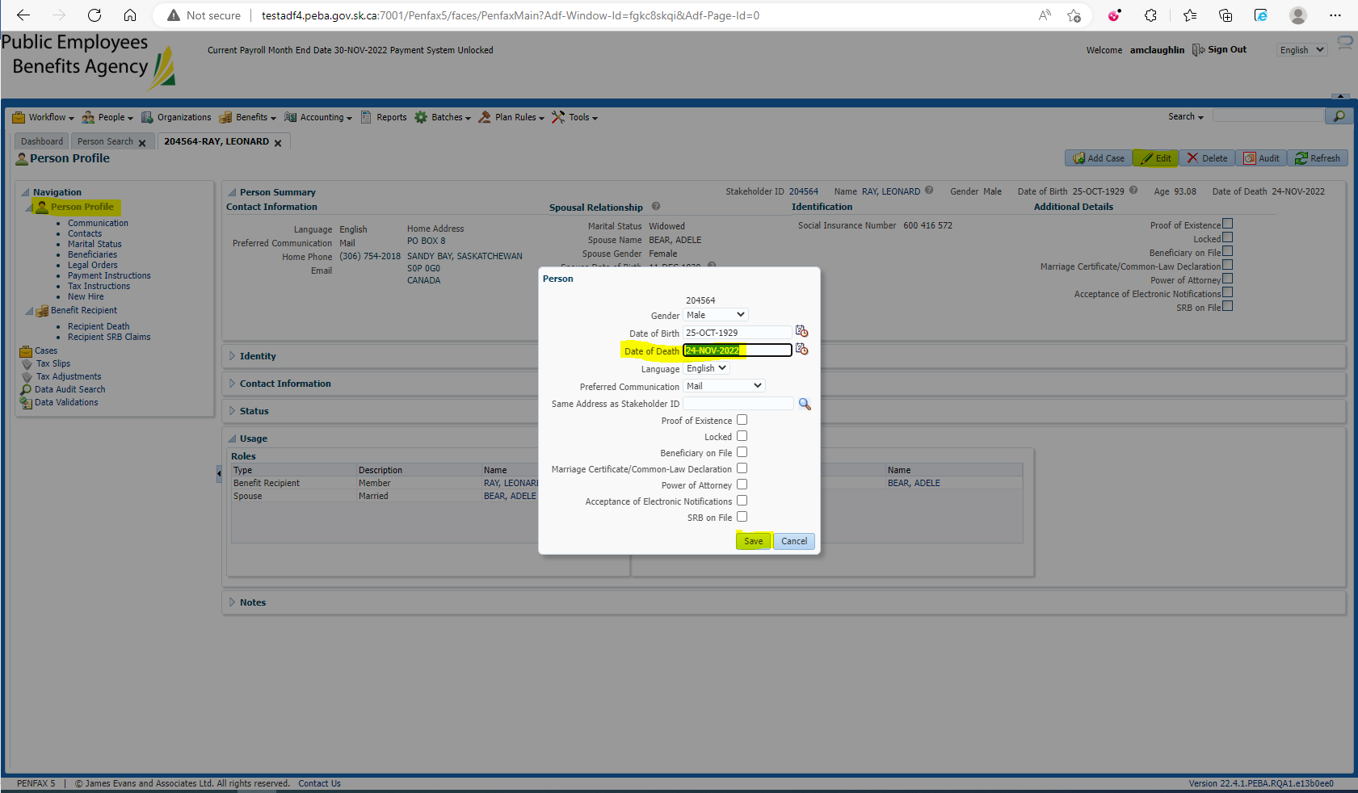

Verify Date of Death is now reflected in the Person Summary 